Enforce least-privilege access through identity-aware,application-specific access policies using Zscalar private access(ZPA)

Group details | Team ID : SWTID-2026-6820  Team Size : 4  Team Leader : ARAVINTHAN M  Team member : GOWTHAM R  Team member : SIVA KUMAR M  Team member : BAIRAVI R
Name | ARAVINTHAN M
College name | Bishop thorp college
contact | aravinthana@gmail.com

Project details:

Title :
Enforce least-privilege access through identity-aware, application-specific access policies using Zscaler Private Access (ZPA).

Introduction :
In an era where the digital landscape is constantly evolving, organizations face an ever-increasing threat from cyberattacks. The need for swift and effective incident response has become paramount to safeguard sensitive
data, protect digital assets, and maintain the trust of stakeholders. In response to this growing challenge, we
present a visionary project: the development of an AI-driven incident response platform that empowers
cybersecurity teams with the tools to automate and enhance incident triage and response tasks.
In response to the evolving threat landscape and the dissolution of the traditional network perimeter,
modern enterprises are rapidly shifting away from legacy VPN-centric remote access models. These
conventional approaches often grant excessive network-level access, creating a significant attack
surface and increasing the risk of lateral threat movement. To address these challenges, this project
centers on the implementation of a Zero Trust security architecture, fundamentally operating on the
principle of "never trust, always verify." By moving beyond location-based access, we aim to establish a
security posture where trust is no longer implicit, and access is determined by granular context rather
than network connectivity.
The core of this initiative involves the deployment of Zscaler Private Access (ZPA), a cloud-delivered
Zero Trust Access solution designed to create identity-aware, application-specific connectivity. Unlike
traditional VPNs that place users on the internal network, ZPA leverages a "service-initiated" model to
establish direct, one-to-one connections between authorized users and specific applications, completely
hiding the corporate network and IP address space from the internet. This ensures that users connect
exclusively to the applications they are permitted to access, based on continuous identity verification
and context, rendering the applications invisible to unauthorized users and preventing common attack
vectors such as port scanning and distributed denial-of-service (DDoS) attacks.
Ultimately, this project will enforce a least-privilege access model, ensuring users and devices are
granted the minimum required access necessary to perform their functions. By decoupling application
access from network access, we will eliminate the risk of lateral movement across the network, as users
have no visibility or connectivity to other hosts. This strategic move not only significantly enhances
security by reducing the attack surface but also simplifies the user experience and reduces operational
overhead associated with legacy remote access infrastructure, positioning the organization at the forefront of secure and efficient access management.
Abstract :
The proliferation of hybrid work and cloud-based resources has rendered traditional perimeter-based security models, such as VPNs, obsolete and increasingly dangerous. These legacy solutions often provide overly broad network access, exposing organizations to significant risks including lateral threat movement and an expanded attack surface. This project addresses these vulnerabilities by implementing a Zero Trust Architecture (ZTA) utilizing Zscaler Private Access (ZPA). The primary objective is to transition from network-centric to identity-centric access, thereby enforcing the principle of least privilege.

The methodology involves deploying ZPA’s cloud-based service to create application-specific, identity-aware micro-tunnels. Unlike conventional VPNs that place users on the internal network, this solution establishes direct, one-to-one connections between verified users and authorized applications. The network infrastructure and all non-authorized applications remain completely invisible to the end-user, effectively eliminating surface for reconnaissance and attack. Access policies are dynamically governedby user identity, device posture, and contextual attributes, ensuring that connectivity is strictly limited to what is explicitly required for specific job functions.
The implementation of ZPA successfully decouples application access from network access, resulting in a demonstrable reduction in the organization's attack surface and the complete prevention of lateral movement. This project delivers a robust, scalable, and user-friendly remote access framework that aligns with modern security best practices. By shifting to an identity-aware, least-privilege model, the organization significantly enhances its security posture while simultaneously reducing operational complexity and improving the end-user experience.

Use case scenarios:

Scenario 1: finance department access to ERP system
A senior accountant in the finance department needs to access the corporate Enterprise Resource Planning (ERP) system to process monthly payroll. The user connects from a remote location using their company-managed laptop. Upon launching the ZPA Client Connector, they authenticate via Azure Active Directory with multi-factor authentication (MFA). ZPA evaluates the user's identity, group membership (Finance_ERP_Users), device posture (antivirus active, disk encryption enabled), and connection context. The policy engine determines that the user is authorized and brokers a secure, direct micro-tunnel to the ERP application only. The user can interact with theERP interface, but has no visibility or network-level access to any other internal systems, such as developmentservers or the HR database.
Output:
• User authenticated and authorized based on identity and group membership
• Direct micro-tunnel established specifically to the ERP application
• All other internal applications and network segments remain invisible and inaccessible

Scenario 2: Contractor Access to Specific Project Repository
An external software consultant is hired for a three-month project and requires access only to a specific Git repository hosted on an internal server. The contractor is onboarded as a guest user in the identity provider and assigned to the "Project_X_Contractors" group. When the contractor connects using the ZPA client, the system verifies their identity and checks the device for basic security compliance (OS patch level, firewall enabled). ZPA enforces a policy that grants access exclusively to the Git repository application (port 22/SSH or port 443/HTTPS)during business hours (9 AM to 5 PM). The contractor can clone, push, and pull code, but cannot discover or connect to any other internal resources, including the corporate intranet or file servers.
Output:
• Time-bound and role-specific access enforced
• Contractor restricted to a single application (Git repository)
• Lateral movement to adjacent systems completely blocked

Scenario 3: Executive Access to Confidential Board Documents
A company executive needs to access a confidential folder containing board meeting materials hosted on an internal file server. The executive connects from a tablet device while traveling internationally. ZPA integrates with the mobile device management (MDM) solution to verify that the tablet is compliant (not jailbroken, passcode enabled, encryption active). Upon successful authentication, ZPA evaluates the policy: "If user is in 'Executive_Board' group AND device is MDM-compliant AND connection is from a trusted country (allowlist), THEN grant access to 'Board_Documents' application." The executive is connected directly to the specific fileshare, and all data in transit is encrypted via TLS. Any attempt to access other shares or network resources is automatically blocked and logged.
Output:
• Context-aware access based on user role, device posture, and geographic location
• Granular access to a specific file share (Board_Documents)
• Comprehensive logging of access events for audit and compliance
Scenario 4: IT Administrator Access to Server Management Interfaces
A systems administrator requires access to management interfaces (SSH for Linux servers and RDP for Windows servers) to perform routine maintenance. Instead of granting VPN access to the entire management network, ZPA is configured to treat each server or management interface as a separate application segment. The administrator authenticates and is presented only with the specific servers they are authorized to manage based on their ITsubgroup (e.g., "Linux_Admins" see only Linux servers; "Windows_Admins" see only Windows servers). When the admin connects via SSH to a Linux server, ZPA creates a direct micro-tunnel to that specific IP and port combination. The admin cannot scan the subnet, access other servers, or initiate connections to non-authorized ports.

Output:
• Micro-segmentation at the individual server/interface level
• Role-based access controlling visibility of specific management consoles
• Elimination of network-level reconnaissance capabilities for admins

Scenario 5: Mergers and Acquisitions Integration
A company acquires a smaller firm and needs to provide the acquired company's HR team with temporary access to the parent company's benefits enrollment application. The acquired company's users are added as external collaborators in the identity provider with limited attributes. ZPA policies are created that specifically grant the "Acquired_HR" group access only to the "Benefits_App" (a web application hosted internally). The acquired users install the ZPA client, authenticate, and are connected directly to the benefits application. Because ZPA provides access without network connectivity, the parent company's entire internal network remains completely hidden and protected. The acquired users cannot ping, scan, or access any other corporate resource. After six months,when the integration is complete and users are migrated to the parent identity system, the temporary policies are revoked.
Output:
• Secure, temporary access provided without network exposure
• Complete network invisibility protecting the parent company's infrastructure
• Simplified deprovisioning through policy revocation rather than complex network changes

Stage 1
Title:
Enforce least-privilege access through identity-aware, application-specific access policiesusing Zscaler Private Access (ZPA).

Overview:
In response to the evolving threat landscape and the dissolution of the traditional network perimeter, modern enterprises are rapidly shifting away from legacy VPN-centric remote access models. These conventional approaches often grant excessive network-level access, creating a significant attack surface and increasing the risk of lateral threat movement. To address these challenges, this project centers on the implementation of a Zero Trust security architecture, fundamentally operating on the principle of "never trust, always verify." By moving beyond location-based access, we aim to establish a security posture where trust is no longer implicit, and access is determined by granular context rather than network connectivity.
The core of this initiative involves the deployment of Zscaler Private Access (ZPA), a cloud-delivered Zero Trust Access solution designed to create identity-aware, application-specific connectivity.
Unlike traditional VPNs that place users on the internal network, ZPA leverages a "service-initiated" model to establish direct, one-to-one connections between authorized users and specific applications, completely hiding the corporate network and IP address space from the internet. This ensures that users connect exclusively to the applications they are permitted to access, based on continuous identity verification and context, rendering the applications invisible to unauthorized users and preventing common attack vectors such as port scanning and distributed denial-of-service (DDoS) attacks. Ultimately, this project will enforce a least-privilege access model, ensuring users and devices are granted the minimum required access necessary to perform their functions. By decoupling application access from network access, we will eliminate the risk of lateral movement across the network, as users have no visibility or connectivity to other hosts. This strategic move not only significantly enhances security by reducing the attack surface but also simplifies the user experience and reduces operational overhead associated with legacy remote access infrastructure, positioning the organization at the forefront of secure and efficient access management.

List of vulnerability:
S.No. | Vulnerability name | CWE.No
1. | Cross-site scripting(stored) | 79
2. | Broken access control | 285
3. | SQL injection | 89
4. | Broken authentication | 285
5. | Insecure direct object reference | 639
6. | Security misconfiguration | 732
7. | Cross-site request forgery | 352
8. | Cleartext transmission of sensitive information | 319
9. | Click jacking | 1021
10. | Webserver allows password auto-completion | 310
11. | Cross-site scripting(DOM-based XSS) | 79
12. | JQuery 1.2<3.5.0 multiple XSS | 79
13. | Information exposure(web server http header internal ip disclosure) | 200
14. | Information exposure(SSL(Multiple issues)) | 200
15. | Information exposure (http(multiple issue)) | 200
16. | OS identification failed | 200

Report:
1. Vulnerability name: Cross site scripting (stored)
CWE: 79
OWASP category: A03:2021 -Injections

Description: It occurs when a malicious script is injected directly into a vulnerable web application.
Reflected XSS involves the reflection of a malicious script of a web application, onto a user's browser.
Business Impact: The application stores dangerous data in a database, message forum, visitor log, or other trusted data store. Later, the dangerous data is subsequently read back into the application and included in dynamic content. From an attacker's perspective, the optimal place to inject malicious content is in an area that is displayed to either many users or particularly interesting users. Interesting users typically have elevated privileges in the application or interact with sensitive data that is valuable to the attacker. If one of these users executes malicious content, the attacker may be able to perform privileged operations on behalf of the user or gain access to sensitive data belonging to the user.

Vulnerability path: http://testfire.net/
Vulnerability parameter: http://testfire.net/search.jsp?query=%27%3E%3Cscript%3Ealert%28%27hacked%27%29%3C%2Fscript%3E

Steps to Reproduce:
➢ Access the URL
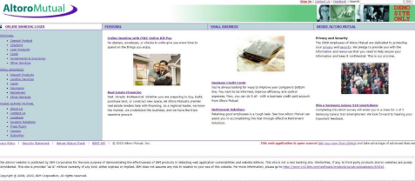

➢ In the search box we will input some code to perform the vulnerability.

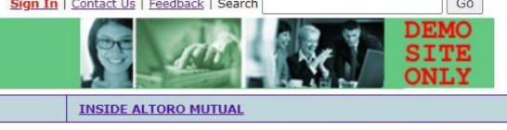
➢ The Script we will be inputting is '><script>alert('hacked')</script>
➢ This displays a harmless pop up alert box with the text saying ‘hacked’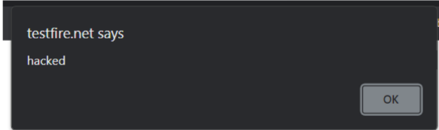
Recommendation:
• When interacting with databases, use parameterized statements or prepared statements to avoid SQL injection, which can be a vector for XSS.
• Sanitize and validate all user inputs and ensure that any data displayed on the web page is properly encoded. Use output encoding libraries or functions to prevent script injection.

2. Vulnerability name: Broken access control
CWE: 285
Description: When access control checks are not applied consistently - or not at all - users are able to access data or perform actions that they should not be allowed to perform. This can lead to a wide range of problems, including information exposures, denial of service, and arbitrary code execution.
Business Impact: wide-ranging business impact, including financial losses, reputation damage, legal consequences, operational disruption, and loss of customer trust. Addressing this vulnerability is crucial to protect the organization and its stakeholders from these potential negative effects.
Vulnerability path: http://testfire.net/
Vulnerability parameter: http://testfire.net/login.jsp
Steps to Reproduce:
➢ Access the URL
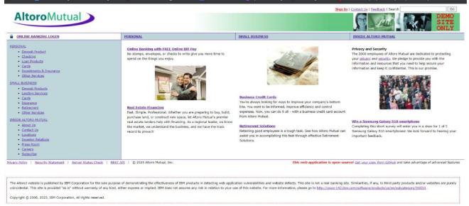
➢ Now we will try to sign in to this website with admin privileges.
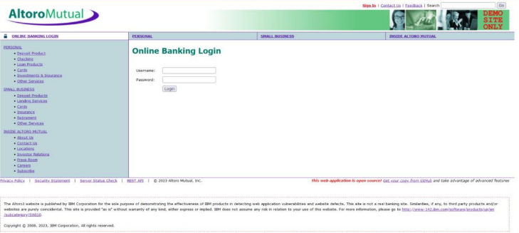
➢ Also, we will be using burp suite to get requests from the website and know additional information.
We use ‘admin’ for the username and password.
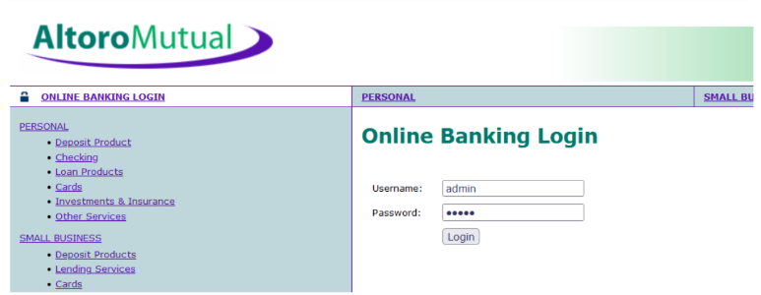
➢ This request has been received in the burp suite with the username and password as well in cleartext.
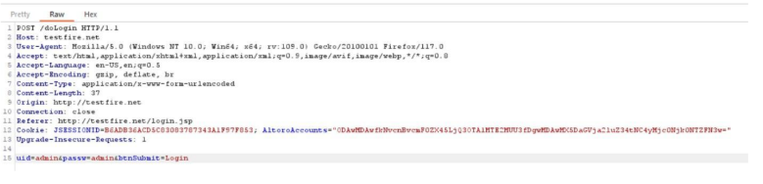
➢ now we click on forward request in the burp suite and then we will be redirected to the admin user Details.
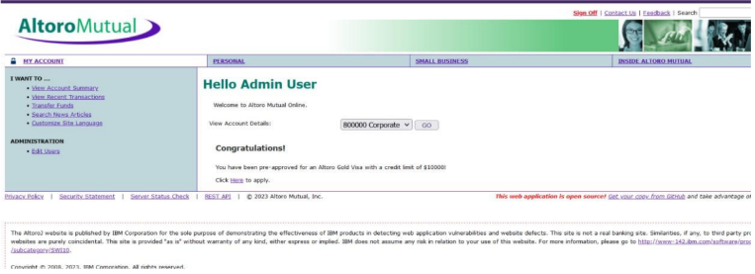
➢ We can even edit the other users data and delete their login details as well.
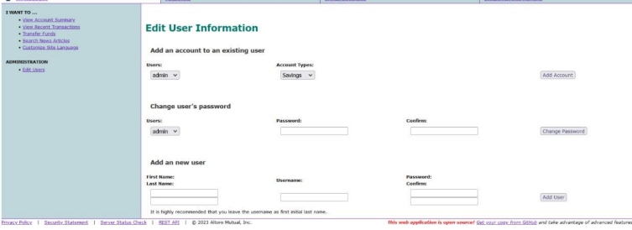

Recommendations:
• Ensure that the application has a robust authentication and authorization mechanism in place. Users should be authenticated before any sensitive actions are performed, and authorization checks should be conducted to verify that users have the necessary permissions for the requested operation.
• Ensure that session management is secure. Use strong session IDs, enforce session timeouts, and regenerate session tokens after login. Implement session fixation protection to prevent session hijacking.

3. Vulnerability name: SQL injection
CWE: 89
Description: The product constructs all or part of an SQL command using externally-influenced input from an upstream component, but it does not neutralize or incorrectly neutralizes special elements that could modify the intended SQL command when it is sent to a downstream component.
Business Impact: In summary, it is crucial to underscore that CWE-89, known as SQL Injection, can exert a profound and diverse business impact. This encompasses critical facets such as data breaches, financial setbacks, harm to reputation, legal ramifications, and operational turmoil. Hence, the imperative of preventing and remedying SQL injection vulnerabilities cannot be overstated, as it is indispensable for fortifying the security and continuity of an organization's applications and data.
Vulnerability path: http://testfire.net/
Vulnerability parameter: http://testfire.net/login.jsp
Steps to Reproduce:
➢ Access the URL

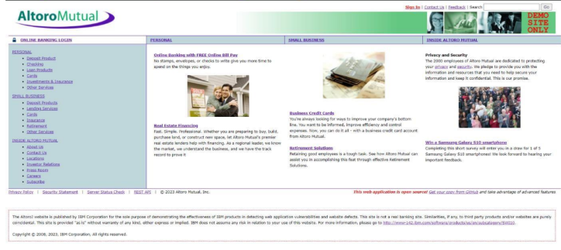
➢ Now we will try to sign in to this website with admin privileges but using SQL injection

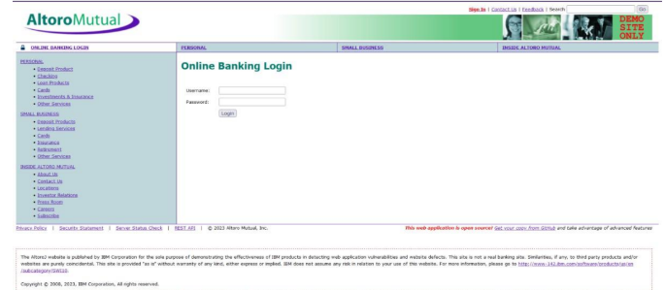
➢ Also, we will be using burp suite to get requests from the website and know additional information.

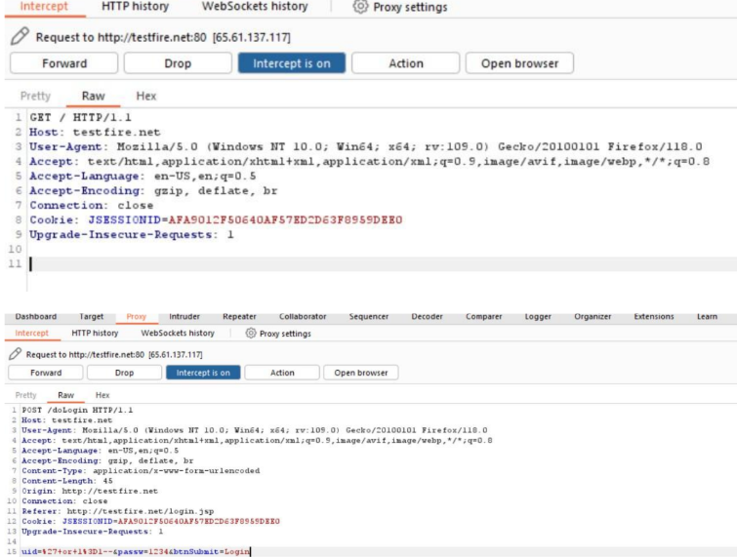
➢ Click forward request multiple times to proceed to the login page.
➢ With this we can know that sql injection worked and we got the admin privileges.
Recommendations:
• If parameterized statements are not feasible, use proper input validation and escaping mechanisms to sanitize user inputs before they are used in SQL queries. This helps prevent malicious code injection.
• Utilize stored procedures for database operations. This can help separate SQL code from application code and reduce the risk of SQL injection.
• Implement strict input validation for all user inputs, ensuring that data adheres to the expected format and structure.

4. Vulnerability name: Broken authentication
CWE: 285

Description: The system's authorization functionality does not prevent one user from gaining access to another user's data or record by modifying the key value identifying the data.
Business Impact: To effectively mitigate the business impact of CWE-285, it is imperative that organizations place a strong emphasis on bolstering their authentication and session management practices. This should encompass the adoption of multi-factor authentication, the secure storage of credentials, meticulous session handling, and a commitment to conducting routine security assessments and testing. The rectification of these vulnerabilities stands as a critical imperative, safeguarding sensitive data, user identities, and the organization's overarching security stature and reputation.
Vulnerability path: http://testfire.net/
Vulnerability parameter: http://testfire.net/login.jsp
Steps to Reproduce:
➢ Access the URL

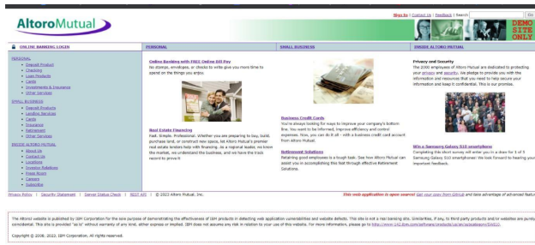
Recommendations:

• Implement strong authentication mechanisms, such as multi-factor authentication (MFA) or two- factor authentication (2FA), to ensure that only authorized users can access the system.
• Implement proper authorization controls to ensure that users have the necessary permissions to access specific functions or data. Use role-based access control (RBAC) to manage user privileges effectively.
• Deploy intrusion detection and prevention systems (IDS/IPS) to monitor and block suspicious activities related to authentication and authorization.
5. Vulnerability Name: Insecure Direct object Reference
CWE: 639
OWASP Category: A01: Broken Access Control
Description:
Insecure Direct Object Reference (IDOR) is a vulnerability that arises when attackers can access or modify objects by manipulating identifiers used in a web application's URLs or parameters. It occurs due to missing access control checks, which fail to verify whether a user should be allowed to access specific data.
Business Impact:
To effectively mitigate the business impact of CWE-639, organizations must make it a top priority to fortify their access control and authorization mechanisms. This entails the implementation of robust security measures, the regular conduct of comprehensive security assessments, and the deployment of intrusion detection systems to promptly identify and counter unauthorized access attempts. These measures stand as absolutely critical in the defense of sensitive data, the overall security of systems, and the preservation of the organization's esteemed reputation.
Vulnerability Path: http://testfire.net
Vulnerability Parameter: http://testfire.net/bank/transfer.jsp

Steps to Reproduce:
➢ Go to the domain.
➢ Sign into the site.
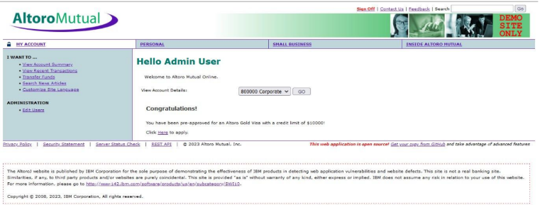
6. Vulnerability name: Security Misconfiguration
CWE:732
Description: The product specifies permissions for a security-critical resource in a way that allows that resource to be read or modified by unintended actors.
Business Impact: To effectively lessen the business consequences stemming from CWE-732, organizations must place a strong emphasis on bolstering their configuration management practices. This involves the establishment of secure default settings, the routine conduct of comprehensive security evaluations, and the deployment of intrusion detection systems to promptly detect and address misconfigurations and vulnerabilities. These actions are of paramount importance in safeguarding sensitive data, fortifying system security, and preserving the organization's esteemed reputation.
Vulnerability path: http://testfire.net/
Vulnerability parameter: http://testfire.net/login.jsp
Steps to Reproduce:
➢ Access the URL
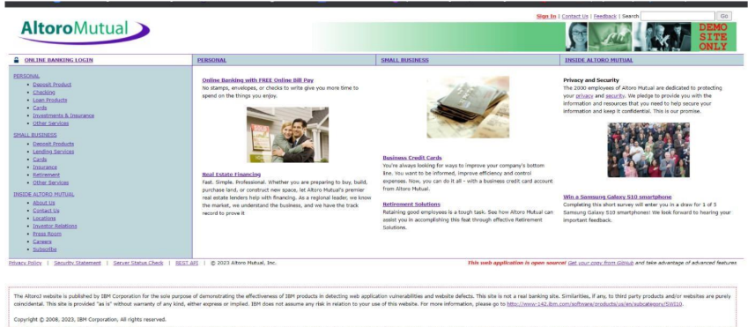
Recommendations:
• Implement a change management process to document and review all changes to system configurations. This helps prevent unauthorized or unintended alterations.
• Follow security guidelines provided by software and hardware vendors to ensure secure configurations.
• Regularly perform compliance checks against industry standards and regulations to ensure that configurations remain in compliance with security requirements.

7. VulnerabilityName: Cross-Site Request Forgery
CWS: 352
OWASP Category: A08: Cross-Site Request Forgery
Description:
Cross-Site Request Forgery (CSRF) is an attack that forces an end user to execute unwanted actions on a web application in which they’re currently authenticated. With a little help of social engineering (such as sending a link via email or chat), an attacker may trick the users of a web application into executing actions of the attacker’s choosing. If the victim is a normal user, a successful CSRF attack can force the user to perform state changing requests like transferring funds, changing their email address, and so forth. If the victim is an administrative account, CSRF can compromise the entire web application.
Business Impact:
To effectively reduce the business repercussions of CWE-352, organizations must prioritize secure coding practices, including the incorporation of anti-CSRF tokens, while also conducting routine security assessments and testing to detect and rectify CSRF vulnerabilities. Furthermore, educating users on secure browsing practices is pivotal in preventing CSRF attacks. These actions are of paramount importance in the protection of data and in upholding the trust of customers and partners.
Vulnerability Path: http://testfire.net/
Vulnerability Parameter: http://testfire.net/bank/transfer.jsp
Steps to Reproduce:
➢ Open https://testfire.net/.
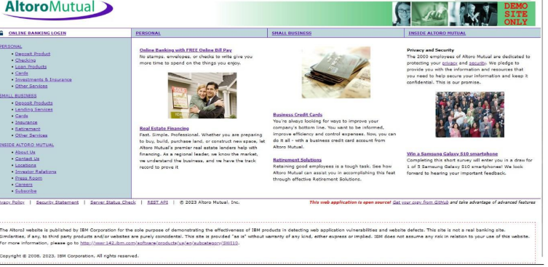

➢ User thinks, he could use a free $100 gift card! What could go wrong? You open the email and click the link/open the attachment.
➢ Once the user opens the form a transaction is automatically performed from his account without his knowledge as the user is already logged in.
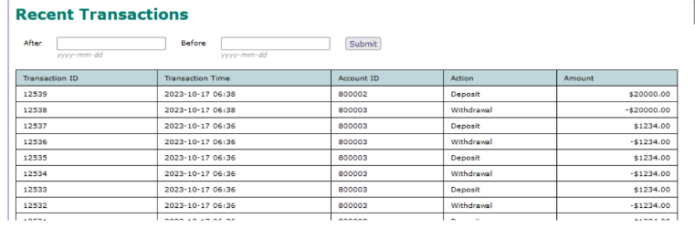
8. Vulnerability name: Cleartext Transmission of Sensitive Information
CWE: 319
Description: The product transmits sensitive or security-critical data in cleartext in a communication channel that can be sniffed by unauthorized actors. Many communication channels can be "sniffed" (monitored) by adversaries during data transmission. For example, in networking, packets can traverse many intermediary nodes from the source to the destination, whether across the internet, an internal network, the cloud, etc. Some actors might have privileged access to a network interface or any link along the channel, such as a router, but they might not be authorized to collect the underlying data. As a result,network traffic could be sniffed by adversaries, spilling security-critical data.
Business Impact: To effectively reduce the business consequences associated with CWE-319, organizations must prioritize the adoption of secure data transmission practices. This includes the utilization of encryption and robust, secure protocols. The routine conduct of security assessments and testing is pivotal in pinpointing and remedying vulnerabilities linked to data transmission. Furthermore, the education of users on secure data handling practices plays a vital role in proactively preventing data exposure incidents. These actions are of paramount importance in the protection of sensitive data and in preserving the trust ofboth customers and partners.
Vulnerability path: http://testfire.net/
Vulnerability parameter: http://testfire.net/login.jsp
Steps to reproduce:
➢ Access the URL
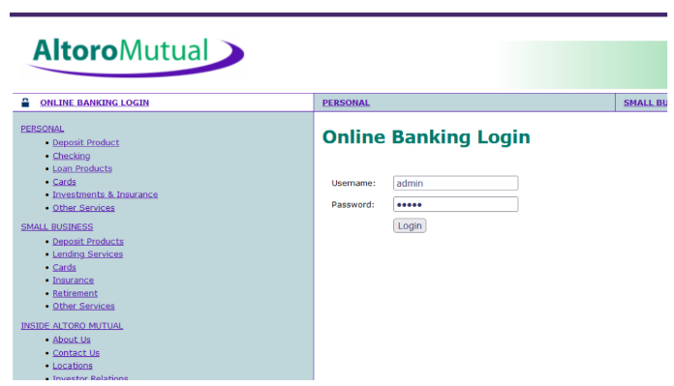
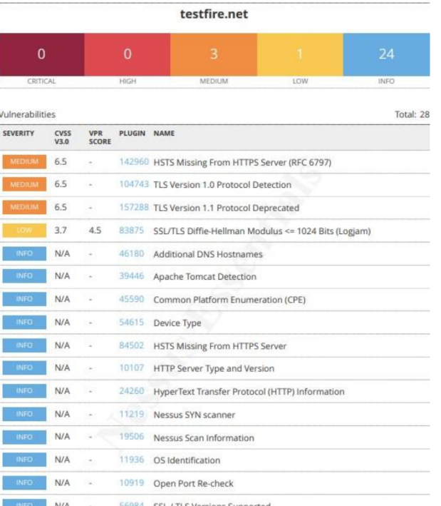

Stage – 2
Overview: -
An overview of a Nessus scan typically involves the following key steps and aspects:
1. Preparation: Define Objectives: Determine the scope and objectives of the scan. What systems or networks do you want to assess, and what specific vulnerabilities are you looking for?
System Access: Ensure that you have the necessary permissions and access rights to scan the target systems or networks.
2. Configuration: Set Up Scan Policy: Create a scan policy that defines the parameters of the scan, such as the types of vulnerabilities to check for, scanning frequency, and specific configurations.
Define Target Assets: Specify the IP addresses, hostnames, or network ranges of the systems you want to scan.
3. Scanning: Initiate Scan: Start the Nessus scan using the configured policy and target assets. Nessus will systematically scan the target systems for vulnerabilities based on its plugins and policies.
4. Vulnerability Identification: Nessus performs a comprehensive assessment, checking for vulnerabilities, misconfigurations, open ports, and other security issues. As the scan progresses, it categorizes vulnerabilities by severity, making it easier to prioritize remediation efforts.
5. Reporting: Nessus generates detailed reports that list the vulnerabilities discovered during the scan. Reports typically include information about the severity of each vulnerability, recommended actions for remediation,and supporting evidence. These reports can be customized and exported in various formats, such as PDF, HTML, or CSV.
6. Remediation: Review Findings: IT and security teams review the Nessus scan reports to prioritize and address the identified vulnerabilities.
Remediation Steps: Take corrective actions to fix or mitigate the vulnerabilities. This may involve applying patches, changing configurations, or implementing security measures.
7. Follow-up: Regular Scanning: Conduct periodic Nessus scans to continuously monitor the security posture of the systems and networks. This helps identify new vulnerabilities and track progress in mitigating existing ones.
Integration: Integrate Nessus with other security tools or workflows to automate the vulnerability management process and streamline the response to new findings.
8. Compliance Auditing (if applicable): If compliance checks are part of your scan policy, review compliance results and take actions to ensure systems meet the required standards and regulations.
9. Documentation: Maintain records of scan results, remediation efforts, and compliance checks for audit and reporting purposes.
10. User Training: Ensure that your IT and security teams are trained in using Nessus effectively and interpreting scan results.
Nessus scans are a critical component of proactive security, helping organizations identify and address vulnerabilities in their IT infrastructure to reduce the risk of security breaches and data compromises. The frequency and depth of scans can vary depending on an organization's security strategy and requirements.
Nessus is a popular vulnerability scanning tool used for identifying security weaknesses in computer systems and networks. It is widely utilized by security professionals and organizations to assess the security posture of their systems and to proactively identify potential vulnerabilities that could be exploited by attackers. Here's what
I understand about Nessus scans:
1. Vulnerability Assessment: Nessus performs a vulnerability assessment by scanning target systems or networks to identify security issues, such as missing patches, misconfigurations, weak passwords, and other potential weaknesses that could be exploited by attackers.
2. Network Scanning: Nessus can scan a wide range of network devices, including servers, routers, switches, firewalls, and more. It examines network services, open ports, and software running on target systems.
3. Plugin Architecture: Nessus uses a plugin-based architecture, allowing it to check for a wide variety of vulnerabilities. These plugins are regularly updated to include the latest security checks and support for new vulnerabilities.
4. Compliance Auditing: It can also be used to assess systems against various compliance standards and regulatory requirements, helping organizations ensure that their systems meet specific security standards, like PCI DSS or CIS benchmarks.
5. Customization: Nessus scans can be customized to suit the specific needs of an organization. Users can define scan policies, select the target systems, and specify the types of vulnerabilities to scan for.
6. Reporting:Nessus provides detailed reports that highlight vulnerabilities, their severity, and remediation recommendations. These reports are essential for IT and security teams to prioritize and address vulnerabilities.
7. Scanning Frequency: Organizations often perform regular Nessus scans to continuously monitor and improve their security posture. This is crucial for staying ahead of evolving threats and vulnerabilities.
8. Integration: Nessus can be integrated with other security tools and platforms, allowing organizations to automate the scanning process and streamline their vulnerability management.
9. Licensing:Nessus offers both free and commercial versions. The free version is limited in its functionality, while the commercial version provides more features and support.
10. User-Friendly Interface: Nessus offers an easy-to-use web-based interface, making it accessible to a wide range of users, from security experts to less experienced IT professionals.
It's important to note that Nessus is a valuable tool for identifying vulnerabilities, but it doesn't fix these vulnerabilities itself. It's up to the organization's IT and security teams to take the necessary steps to remediate the identified issues to enhance their security.

Target Website: testfire.net
Target IP Address: 54.83.41.36
Report:
1. VULNERABILITY NAME: Cross site scripting (stored)
SEVERITY: Low
PLUGIN: web application scanner
PORT: N/A
DESCRIPTION: It occurs when a malicious script is injected directly into a vulnerable web application. Reflected XSS involves the reflection of a malicious script of a web application, onto a user's browser.
SOLUTION:
• When interacting with databases, use parameterized statements or prepared statements to avoid SQL injection, which can be a vector for XSS.
• Sanitize and validate all user inputs and ensure that any data displayed on the web page properly encoded. Use output encoding libraries or functions to prevent script injection.
BUSINESS IMPACT: The application stores dangerous data in a database, message forum, visitor log, or other trusted data store. Later, the dangerous data is subsequently read back into the application and included in dynamic content. From an attacker's perspective, the optimal place to inject malicious content is in an area that is displayed to either many users or particularly interesting users. Interesting users typically have elevated privileges in the application or interact with sensitive data that is valuable to the attacker. If one of these users executes malicious content, the attacker may be able to perform privileged operations on behalf of the user or gain access to sensitive data belonging to the user.
2. VULNERABILITYNAME: Broken access control
SEVERITY: medium
PLUGIN:SSH weakHMAC Algorithms supported
PORT: N/A
DESCRIPTION: When access control checks are not applied consistently - or not at all - users are able to access data or perform actions that they should not be allowed to perform. This can lead to a wide range of problems, including information exposures, denial of service, and arbitrary code execution.
SOLUTION:
• Ensure that the application has a robust authentication and authorization mechanism in place. Users should be authenticated before any sensitive actions are performed, and authorization checks should be conducted to verify that users have the necessary permissions for the requested operation.
• Ensure that session management is secure. Use strong session IDs, enforce session timeouts, and regenerate session tokens after login. Implement session fixation protection to prevent session hijacking.
BUSINESS IMPACT: wide-ranging business impact, including financial losses, reputation damage, legal consequences, operational disruption, and loss of customer trust. Addressing this vulnerability is crucial to protect the organization and its stakeholders from these potential negative effects.
3. VULNERABILITY NAME: SQL injection
SEVERITY: medium
PLUGIN: N/A (typically would be a security testing tool)
PORT: port 80/443
DESCRIPTION: The product constructs all or part of an SQL command using externally influenced input from an upstream component, but it does not neutralize or incorrectly neutralizes special elements that could modify the intended SQL command when it is sent to a downstream component.
SOLUTION:
• If parameterized statements are not feasible, use proper input validation and escaping mechanisms to sanitize user inputs before they are used in SQL queries. This helps prevent malicious code injection.
• Utilize stored procedures for database operations. This can help separate SQL code from application code and reduce the risk of SQL injection.
• Implement strict input validation for all user inputs, ensuring that data adheres to the expected format and structure.
BUSINESS IMPACT: In summary, it is crucial to underscore that CWE-89, known as SQL Injection, can exert a profound and diverse business impact. This encompasses critical facets such as data breaches, financial setbacks, harm to reputation, legal ramifications, and operational turmoil. Hence, the imperative of preventing and remedying SQL injection vulnerabilities cannot be overstated, as it is indispensable for fortifying the security and continuity of an organization's applications and data.
4. VULNERABILITYNAME: Broken authentication
SEVERITY: Low
PLUGIN: HSTS Missing from HTTPS Server (plugin id:142960)
PORT: port 443

DESCRIPTION: The system's authorization functionality does not prevent one user from gaining access to another user's data or record by modifying the key value identifying the data.
SOLUTION:
• Implement strong authentication mechanisms, such as multi-factor authentication (MFA) or two-factor authentication (2FA), to ensure that only authorized users can access the system.
• Implement proper authorization controls to ensure that users have the necessary permissions to access specific functions or data. Use role-based access control (RBAC) to manage user privileges effectively.
• Deploy intrusion detection and prevention systems (IDS/IPS) to monitor and block suspicious activities related to authentication and authorization.
BUSINESSIMPACT: To effectively mitigate the business impact of CWE-285, it is imperative that organizations place a strong emphasis on bolstering their authentication and session management practices. This should encompass the adoption of multi-factor authentication, the secure storage of credentials, meticulous session handling, and a commitment to conducting routine security assessments and testing. The rectification of these vulnerabilities stands as a critical imperative, safeguarding sensitive data, user identities, and the organization's overarching security stature and reputation.
5. VULNERABILITYNAME: Insecure Direct object Reference
SEVERITY: Info
PLUGIN:Service Detection (plugin id:22964)
PORT: port 80/443
DESCRIPTION: Insecure Direct Object Reference (IDOR) is a vulnerability that arises when attackers can access or modify objects by manipulating identifiers used in a web application's URLs or parameters. It occurs due to missing access control checks, which fail to verify whether a user should be allowed to access specific data.
SOLUTION:
• Utilize parameterized queries or prepared statements when interacting with databases. This prevents user-controlled input from being executed as SQL code.
• Implement a Content Security Policy to mitigate the risk of cross-site scripting (XSS) attacks, which can be used to execute unauthorized queries.
• Implement account lockout mechanisms that temporarily suspend accounts after a specified number of unauthorized access attempts to prevent brute force attacks.
BUSINESS IMPACT: To effectively mitigate the business impact of CWE-639, organizations must make it a top priority to fortify their access control and authorization mechanisms. This entails the implementation of robust security measures, the regular conduct of comprehensive security assessments, and the deployment of intrusion detection systems to promptly identify and counter unauthorized access attempts. These measures stand as critical in the defence of sensitive data, the overall security of systems, and the preservation of the organization's esteemed reputation.
6. VULNERABILITY NAME: Security Misconfiguration

SEVERITY: low
PLUGIN: SSL cipher Block chaining cipher suites
PORT: port 443
DESCRIPTION: The product specifies permissions for a security-critical resource in a way that allows that resource to be read or modified by unintended actors.
SOLUTION:
• Implement a change management process to document and review all changes to system configurations. This helps prevent unauthorized or unintended alterations.
• Follow security guidelines provided by software and hardware vendors to ensure secure configurations.
• Regularly perform compliance checks against industry standards and regulations to ensure that configurations remain in compliance with security requirements.
BUSINESS IMPACT: To effectively lessen the business consequences stemming from CWE-732,
organizations must place a strong emphasis on bolstering their configuration management practices. This involves the establishment of secure default settings, the routine conduct of comprehensive security evaluations, and the deployment of intrusion detection systems to promptly detect and address misconfigurations and vulnerabilities. These actions are of paramount importance in safeguarding sensitive data, fortifying system security, and preserving the organization's esteemed reputation.
7. VULNERABILITYNAME: Cross-Site Request Forgery
SEVERITY: Low
PLUGIN:HTTP Form-Based Authentication Detected
PORT: port 8080/443
DESCRIPTION: Cross-Site Request Forgery (CSRF) is an attack that forces an end user to execute unwanted actions on a web application in which they’re currently authenticated. With a little help of social engineering (such as sending a link via email or chat), an attacker may trick the users of a web application into executing actions of the attacker’s choosing. If the victim is a normal user, a successful CSRF attack can force the user to perform state changing requests like transferring funds, changing their email address, and so forth. If the victim is an administrative account, CSRF can compromise the entire web application.
SOLUTION:
• Implement Synchronizer Token Patterns to include unique, randomly generated tokens in each HTTP request and validate these tokens on the server side to verify the authenticity of the request.
• Utilize the Same Site attribute in cookies to restrict their usage to same-site requests only, preventing them from being sent along with cross-site requests and effectively mitigating CSRF attacks.

• Utilize framework-specific protections and security features to prevent CSRF attacks. Many modern web frameworks have built-in mechanisms and libraries for handling CSRF vulnerabilities effectively.
• Implement a Content Security Policy to restrict the sources from which various types of content can be loaded. By specifying the trusted sources of content, you can minimize the risk of malicious code execution and reduce the likelihood of successful CSRF attacks.
BUSINESS IMPACT: To effectively reduce the business repercussions of CWE-352, organizations must prioritize secure coding practices, including the incorporation of anti-CSRF tokens, while also conducting routine security assessments and testing to detect and rectify CSRF vulnerabilities.
Furthermore, educating users on secure browsing practices is pivotal in preventing CSRF attacks.These actions are of paramount importance in the protection of data and in upholding the trust of customers and partners.
8. VULNERABILITYNAME: Cleartext Transmission ofSensitive Information
SEVERITY: Medium
PLUGIN: Cleartext Transmission ofSensitive Information overHTTP
PORT: port 443
DESCRIPTION: The product transmits sensitive or security-critical data in cleartext in a communication channel that can be sniffed by unauthorized actors. Many communication channels can be "sniffed" (monitored) by adversaries during data transmission. For example, in networking, packets can traverse many intermediary nodes from the source to the destination, whether across the internet, an internal network, the cloud, etc. Some actors might have privileged access to a network interface or any link along the channel, such as a router, but they might not be authorized to collect the underlying data. As a result, network traffic could be sniffed by adversaries, spilling security-critical data.
SOLUTION:
• Educate users and employees on secure data handling practices, such as recognizing secure websites (look for "https") and avoiding insecure Wi-Fi networks.
• Employ data masking or redaction techniques to replace sensitive data with placeholders or cryptographic representations during transmission.
• Implement encryption for data in transit. Use secure encryption protocols such as TLS/SSL to protect sensitive information during transmission.
• Use secure communication protocols for transmitting data, such as HTTPS for web applications, and ensure that the selected protocols are kept up to date.
BUSINESSIMPACT: To effectively reduce the business consequences associated with CWE-319, organizations must prioritize the adoption of secure data transmission practices. This includes the utilization of encryption and robust, secure protocols. The routine conduct of security assessments and testing is pivotal in pinpointing and remedying vulnerabilities linked to data transmission.
Furthermore, the education of users on secure data handling practices plays a vital role in proactively preventing data exposure incidents. These actions are of paramount importance in the protection of sensitive data and in preserving the trust of both customers and partners.
9. VULNERABILITY NAME: Clickjacking

SEVERITY: Info
PLUGIN:HTML Rendering Layer Vulnerability
PORT: port 80/443
DESCRIPTION: The web application does not restrict or incorrectly restricts frame objects or UI layers that belong to another application or domain, which can lead to user confusion about which interface the user is interacting with.
SOLUTION:
• Set the X-Frame-Options HTTP response header to deny or same-origin to control how your site can be framed. This is supported by most modern browsers.
• Utilize frame-busting JavaScript code in web applications to prevent the embedding of your site within malicious frame’s. This code can disrupt clickjacking attempts.
• Implement a Content Security Policy to restrict which domains can embed your site in iframes. This can help prevent unauthorized framing.
• Implement additional security controls to prevent UI redress attacks, such as clickjacking, within your web application.
BUSINESS IMPACT: To effectively reduce the business consequences resulting from CWE-1021,
organizations must prioritize the implementation of protective measures, such as frame-busting code. Simultaneously, educating users on safe browsing practices plays a crucial role in preventing clickjacking incidents. Additionally, routine security assessments and testing are pivotal for identifying and mitigating vulnerabilities associated with clickjacking. These actions are of
paramount importance in upholding user trust, ensuring data protection, and safeguarding the organization's reputation.
10. VULNERABILITY NAME: web server allows password auto-completion
SEVERITY: Low
PLUGIN: SSL/TLS Diffie-Hellman Modulus <= 1024 Bits (Logjam)
PORT: port 443
DESCRIPTION: Weaknesses in this category are related to the design and implementation of data confidentiality and integrity. Frequently these deal with the use of encoding techniques, encryption libraries, and hashing algorithms. The weaknesses in this category could lead to a degradation of the quality data if they are not addressed.
SOLUTION:
• Implement secure password storage mechanisms, such as using strong and salted cryptographic hashing algorithms like crypt or script.
• Implement robust encryption key management practices, including secure key storage, key rotation, and access controls.
• Utilize well-established and proven cryptographic libraries and algorithms for encryption and decryption.
• Use secure encryption protocols, like TLS/SSL, for data transmission over networks to protect data in transit
BUSINESS IMPACT: To effectively lessen the business consequences associated with CWE-310,
organizations must prioritize the adoption of secure cryptographic practices. This entails ensuring proper password storage and robust encryption key management. Simultaneously, conducting routine security assessments and testing is pivotal in detecting and mitigating vulnerabilities related to cryptographic issues. Striving for compliance with pertinent data protection regulations and industry standards is equally essential. These actions are of paramount importance in the protection of sensitive data, the upholding of user trust, and the preservation of the organization's esteemed reputation.

